

#### **Water Facts**

**Public Water System Annual Report\***

**-2024-**

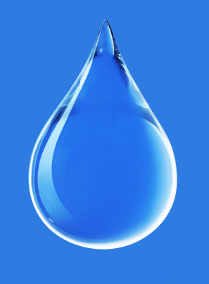

Vince Hiebert, Manager (204) 685-2211

YHRC Emergency Numbers

(204) 871-2425 (North Norfolk)

(431) 554-2332 (Westlake-Gladstone)

(204) 841-3742 (Glenella-Lansdowne)

* The Yellowhead Regional Water Co-op provides potable drinking water to a population of approximately 3,500 people.
* Public water systems are required to monitor chlorine levels and undertake regular bacterial testing.
* The water treatment process removes particulate and organic matter, softens the water to an acceptable level, filters the water, removes taste and odour, and disinfects the water with chlorine to prevent bacterial diseases.

*This is a summary of the full report. Full report available upon request.

# ***Yellowhead Regional Water Co-op Inc.***

***Yellowhead Regional***

***Water Co-op Inc.***

# **Monitoring**

The Province of Manitoba has adopted a number of water quality standards from the *Guidelines for Canadian Drinking Water Quality*, developed by Health Canada. The health-based parameters express the maximum acceptable concentrations for drinking water.

Regular monitoring and reporting include disinfectant residual levels, bacteriological sampling, and disinfection by-products testing.

The YHRC Public Water System fulfilled its obligation in 2024 in complying with *The Drinking Water Safety Act* regulations, except for exceeding HAA limits at times.

In 2024 There were no incidents that compromised the safety of the water throughout the YRWC. There were also no warnings issued or charges laid under *The Drinking Water Safety Act*.

If needed, Corrective actions were taken and reported as required for normal minor variations and non-compliance events during the course of operations.

# **City of Portage la Prairie Water Treatment Process**

The treatment process consists of suspended solids removal pre-treatment, lime softening and clarification, pH adjustment with re-carbonation, ozonation, filtration, taste and odour removal, fluoridation, corrosion control, and disinfection by chlorination.

Chlorine is used to maintain a residual disinfectant in the distribution system. The regional system includes re-chlorination at water storage reservoirs to maintain adequate chlorine levels, and booster pumping stations are used to maintain water pressure.

The treatment system ensures that the water leaving the WTP meets the *Guidelines for Canadian Drinking Water Quality* and the *Drinking Water Safety Act* requirements. However, the contact time in distribution pipelines allows chlorine to react with the water, producing Trihalomethanes (THM) and Haloacetic Acids (HAA). The THM regulation limit is at times exceeded within the YHRC water system.

#### **Yellowhead Regional Water Co-op Inc. (YHRC)**

# **Water System Information**

The Yellowhead Regional Water Co-op (YHRC) water supply system consists of a network of pressurized pipelines, booster stations, a pressure reducing station, and storage reservoirs, the newest being the PBIP reservoir.

The YHRC owns Arden, Austin, Gladstone, MacGregor and Plumas water storage reservoirs, as well as the Lansdowne, Poplar Bluff and Bagot pressure booster stations, and the Westbourne pressure reducing station. The Westbourne Reservoir was taken out of service in 2018, with those customers now being supplied directly from the YHRC main line.

The treated water is supplied by the City of Portage la Prairie Water Treatment Plant (WTP), which uses the Assiniboine River as a raw water source.

The YHRC system provides treated water to approximately 3,500 residents in: Municipalities of Glenella-Lansdowne, Westlake-Gladstone, and North Norfolk; the Towns of MacGregor and Gladstone; and the Villages of Austin, Arden, Bagot, Rossendale, Westbourne, Plumas, and Langruth.